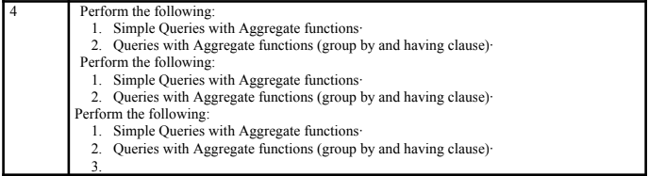
===================================================================
COMMAND:
CREATE TABLE sales1400 (
sale_id INT,
product VARCHAR(8),
region VARCHAR(8),
amount INT,
salesperson VARCHAR(8)
);

INSERT INTO sales1400 VALUES (1, 'Laptop', 'North', 75000, 'Alice');
INSERT INTO sales1400 VALUES (2, 'Mobile', 'South', 30000, 'Bob');
INSERT INTO sales1400 VALUES (3, 'Tablet', 'North', 20000, 'Alice');
INSERT INTO sales1400 VALUES (4, 'Laptop', 'East', 80000, 'Charlie');
INSERT INTO sales1400 VALUES (5, 'Mobile', 'West', 28000, 'Bob');
INSERT INTO sales1400 VALUES (6, 'Laptop', 'North', 70000, 'David');
INSERT INTO sales1400 VALUES (7, 'Tablet', 'South', 22000, 'Alice');

SELECT * FROM sales1400;

SELECT region, SUM(amount) AS total_sales FROM sales1400 GROUP BY region;

SELECT salesperson, COUNT(*) AS products_sold FROM sales1400 GROUP BY salesperson;

SELECT product, AVG(amount) AS avg_amount FROM sales1400 GROUP BY product;

SELECT region, SUM(amount) AS total_sales FROM sales1400 GROUP BY region HAVING SUM(amount) > 100000;

SELECT product, AVG(amount) AS avg_amount FROM sales1400 GROUP BY product HAVING AVG(amount) > 25000;

SELECT region, SUM(amount) AS total_sales FROM sales1400 GROUP BY region ORDER BY total_sales DESC;

SELECT salesperson, SUM(amount) AS total_sales FROM sales1400 GROUP BY salesperson ORDER BY total_sales ASC;

OUTPUT:
